AGE APPROPRIATE ACTIVITIES FOR DEVELOPING NUMERICAL LITERACY

The small NumbersAlive! number characters can be valuable aids for increasing numerical literacy from birth through elementary school. Here are some ideas of how to use the small plush numbers. If you have other ideas, please send them to numbers@numbersalive.org.

GREAT IDEAS FOR BIRTH TO 3 YEARS OF AGE, DEPENDING ON THE CHILD.

Expose your child to the number characters as decorations around their room.

- The small plush number characters stick together with internal magnets on both sides of their heads. The number characters can hang on the wall or as a mobile for infants to see when looking up from the crib or when standing.

- Caregivers can rearrange the magnetic number characters. The photo below shows one possibility using a hanging photo mobile (without clips). Any medium-weight wire will work if the material is “ferromagnetic.” (Aluminum will not work). For safety issues, make sure the metal is away from any child under one year of age.
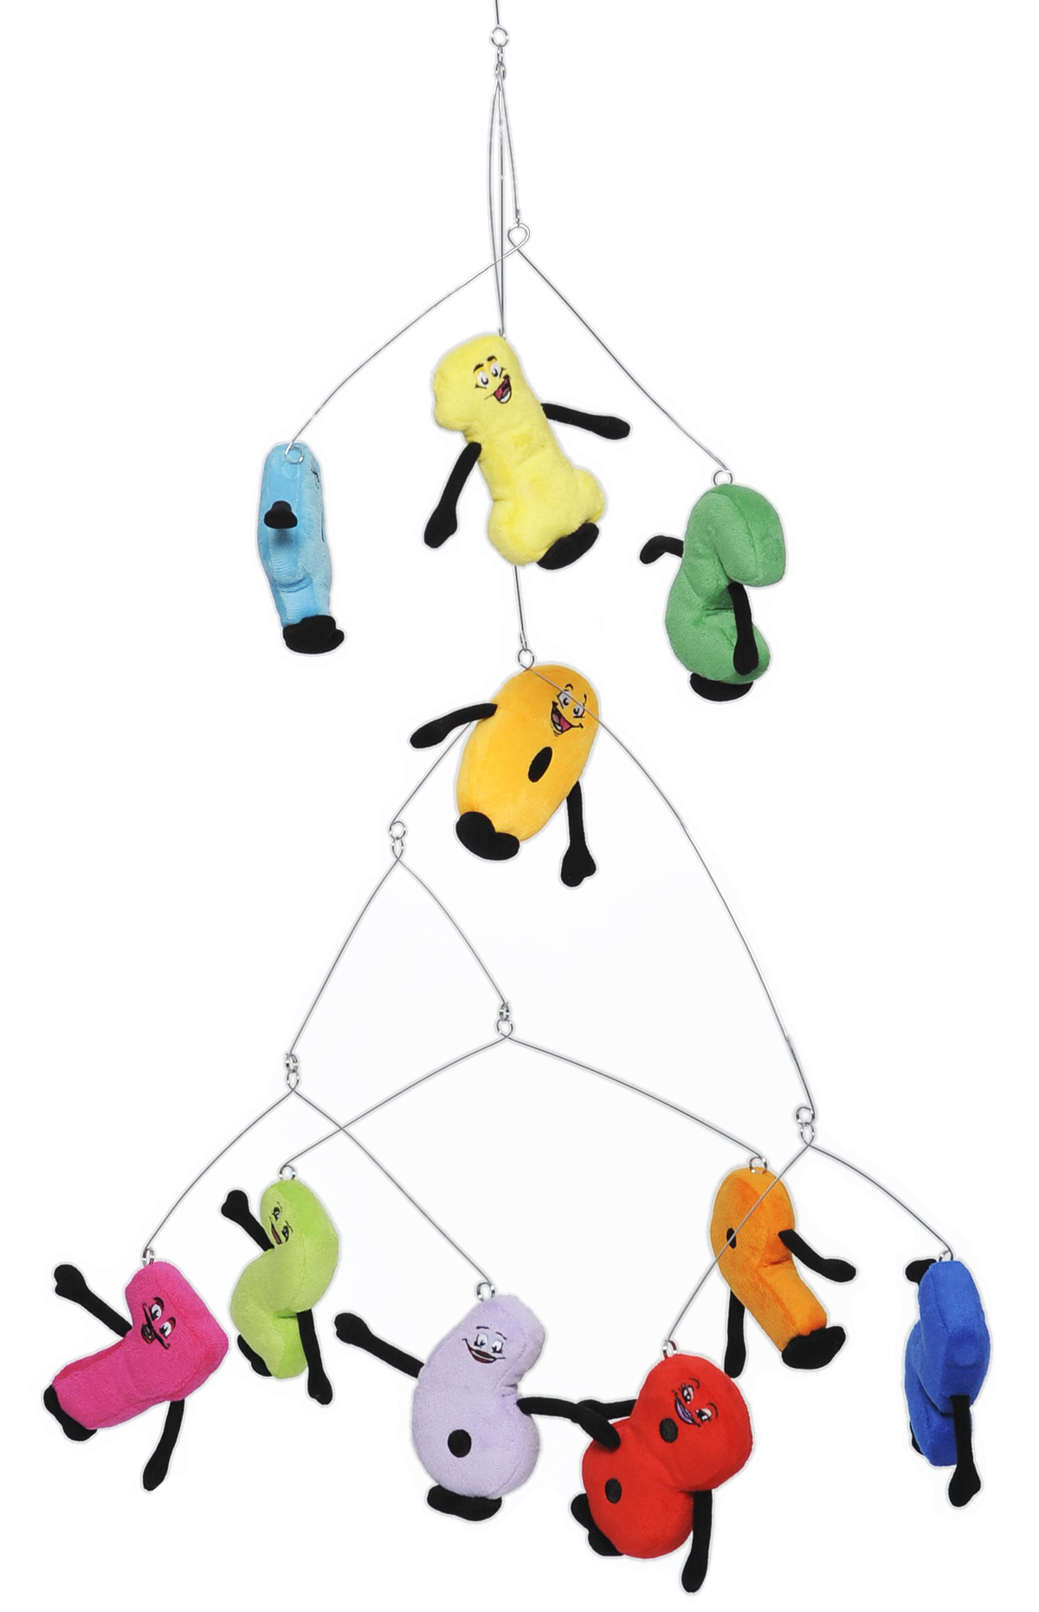

Begin showing the names of the NumbersAlive! characters and their quantity meaning.

- Place a plush number on the floor or a table.
Point to the number and name it.
Arrange all numbers in the numberline order, 0-9. Count forward and backward.
Show how to construct 10.
More difficult: Skip every other number and count by twos.

- Relate the number character to its quantity meaning.
- Turn each number character over and feel embroidered dots that illustrate the
- Discuss the difference in the embroidered quantity dots with the large embroidered oval (0), circles (6, 8 and 9) and triangle (4).
- The large shapes on the front and back remind the child the shape has a ‘hole’ in it.

- Discover the value of sorting groups of items.
- Find objects that are part of the child’s environment, such as stuffed animals, toys, coins, or types of clothing, and put them into groups: by color, shape, purpose, person gifting the items, etc.
- Place the number character representing the correct quantity beside the group. Look again at the quantity embroidered on the back, which begins to illustrate one-to-one matching, if the quantity is less than 9.

GREAT IDEAS FOR TWO TO 10 YEARS OF AGE, DEPENDING ON THE CHILD.

Learn about magnet polarity and types of materials that are not “ferromagnetic.”

Notice how the NumbersAlive! plush numbers ‘jump’ together to become multi-digit numbers when they get close to each other. Or, how they ‘reject’ each other when backwards or upside down.¹

Go on a number scavenger hunt to find numbers in the child’s environment.

Let a child select a number or assign one or more numbers to each child in a group.
Have the child (children) wander around the room, hall, street, yard, etc. finding things that relate to the number(s) in quantity, shape, name or order. Help the child (children) take photos or make drawings of the number-linked items they discovered. Examples of number recognition and number recognition in quantity, shape, name & order follow.

Number Recognition
- Numbers on a clock
- Digital read-outs on electronics
- Numbers in newspapers, magazines, and books
- Mail addresses
- Numbers on street signs and buildings

Number Quantity Recognition (start with 4 for some simple examples)
- Chair or table with four legs
- TV, photo, or picture frame with four sides
- A fork with four tines

Number Shape Recognition (shapes/polygons with the same number of points as the number)
- Square, rectangle, or diamond-shaped windows for 4
- Triangles in architecture for 3
- Flooring constructed with hexagons for 6
- Pentagonal bolts on fire hydrants for 5

Number Name Recognition
- Fifth Street or Fifth Avenue for 5
- Twin as an example of 2’s quantity
- Triplet or tri- as a meaning of 3

Number Order Recognition
- 1st place ribbon or gold medal for 1
- Last place depends on number of entries
Have the children draw or assemble photos of the recognition (“number linkages”) they identified.

Then have the child (children) make a book of the photos they took or drawings they
made during their number scavenger hunt.

See the photographic numbers scavenger hunt on the parent/teacher pages (www.numbersalive.org/parents and www.numbersalive.org/teachers) for an example of how to turn this into a classroom or group activity.

Create Number Stories

- Following from the number scavenger hunt, have the learner or group of learners create number stories.
- Listen to the Hello Numbers CD, read the Hello Numbers book and interact with the Hello Numbers free tablet app for other ideas.
- Give the NumbersAlive! plush numbers special names.
- Use the plush number characters to communicate ideas.²

Construct Multi-digit Numbers (“Number Words”) and Discuss Patterns, Rearrangements/permutations, and the Base 10 Place-value System

Place two small numbers together to create a 2-digit number and then rearrange them to make other combinations, like 56 and 65, for example.³

- Continue the above activity with three individual numbers. For example: 5, 6 and 7. What is the difference in meaning of 567 and 765? How many different arrangements can you make with 3 different numbers? What do we call the
various constructed multi-digit numbers and how do the different arrangements differ in meaning?
- Continue by adding a 4th, 5th, 6th, 7th, 8th, 9th and 10th digit.
- Ask the child (children): What is the largest number you can make with one set of plush numbers, 0-9?
- Then ask the child (children): What is the next-to-largest number you can make with one set of plush numbers, 0-9?

Begin Creating Numbers with Decimals.

- Create a “dot” to represent a decimal using a small piece of paper, cardboard, or find a small ball. Find this dot on your phone’s calculator, on your computer’s calculator, etc.
- Move the decimal to different spaces between the numbers and discuss the different meanings.

Investigate the Base 2 (Binary) numbering system used by the computer.

- Create each number 0-9 (or higher) in binary. Have the child (children) discuss how easy/difficult it is to understand the quantity as the number of 0’s and 1’s gets long. Ask the child (children): “When does the string get hard to read?”

END NOTES:

¹Magnets are contained in a small cloth bag, and the bag is sewn into the seams of the number character. This safe design allows the magnets to move around inside the bag. You may need to adjust the magnets bag to get it back into the intended position.
Since the number characters are constructed of fabric, they can hang together from the corners. Usually such connections create a weak link. Use these experiences as lessons about magnets within a soft, fun engaging object. Contact us if you have questions or difficulty with any of the above.

²This activity has been considered fun by numerically gifted children and those on the autistic spectrum.

³To make 11 and other “twin” numbers, create a second ‘1’. One way is by making and coloring a paper cutout. The set of each number 0-9 will allow for the creation of all numbers 0-98 other than the “twin” numbers 11, 22, 33, 44, 55, 66, 77, 88, 99.
If interested, you can obtain a second set of the numbers.

